Linux - CRON

# Overview

Make linux run scheduled tasks.

# CRON

## Crontabs

Each linux user has their own set of scheduled tasks, defined in their crontab. crontabs can be viewed using the crontab command:

crontab -l

Using sudo shows the root crontab, which allows for scheduled tasks which require root access:

sudo crontab -l

There is also a systemwide crontab:

less /etc/crontab

## Syntax

Cron jobs are entered into the crontab in the following format:

# m h dom mon dow command

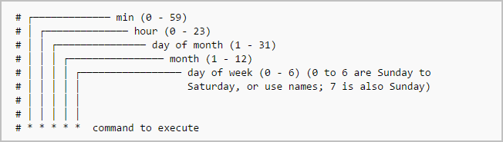

Note the command is run in a shell, and therefore can be the path to a shell script (.sh)

To keep things organised, common shared cron tasks are kept in their respective directories. For example, daily tasks are kept in ```/etc/cron.daily/```.

# Systemd Timers

Systemd can also be used for cron tasks via its timers functionaility. To view timers use:

systemctl list-timers

# Log Rotation

One of the standard cron jobs on linux is log rotation. This archives logs files on the system and keeps a set number in order to maintain system disk storage space.

The default log rotation configuration is:

sudo vim /etc/logrotate.conf

specific log rotation file installed by programs are placed in the /etc/logrotate.d/ directory. These can be edited to manage log files differently.

<https://www.linode.com/docs/uptime/logs/use-logrotate-to-manage-log-files/>

<https://www.thegeekstuff.com/2010/07/logrotate-examples/>